**Design and Simulation of Microstrip Antenna at 5Ghz**

StudentName:Ankushverma Reg . No.: 200907058 Email id: ankush.verma@learner.manipal.edu

*Abstract*— The micro strip line feed antenna is a popular type of planar antenna that is widely used in modern wireless communication systems such as cellular phones, Wi-Fi routers, and other wireless communication applications. It consists of a thin metal patch that is mounted on top of a dielectric substrate with a ground plane underneath. The patch is usually fed using a microstrip line, which is a type of transmission line made of a thin strip of metal on top of the dielectric substrate. The microstrip line feed antenna has several advantages over other types of antennas, including low profile, low cost, and ease of integration with electronic circuits.

The design of a microstrip line feed antenna involves determining the dimensions and parameters of the radiating patch and the microstrip line feed to achieve the desired operating frequency, bandwidth, and radiation pattern. The ANSYS HFSS software is a powerful electromagnetic simulation tool that is widely used for the design and analysis of microwave and radio frequency devices, including antennas. It allows designers to simulate the behavior of complex electromagnetic structures and analyze their performance using various parameters.

The substrate material used for the microstrip line feed antenna in this project is Rogers RT/Duroid 5880, which has a low dielectric constant of 4.4 and a thickness of 1.6 mm. The dimensions of the radiating patch and the microstrip line feed are optimized using ANSYS HFSS to achieve the desired operating frequency of 5 GHz. The simulation results are analyzed to determine the antenna's performance based on parameters such as return loss, radiation pattern, and gain.

Return loss is a measure of the antenna's impedance matching and is a critical parameter for the antenna's performance. A low return loss indicates good impedance matching and efficient power transfer between the antenna and the transmission line. The radiation pattern of the antenna is another important parameter that describes how the antenna radiates energy into space. The gain of the antenna is a measure of its ability to concentrate radiation in a particular direction.

In conclusion, the design and simulation of a microstrip line feed antenna at 5 GHz using ANSYS HFSS is a complex process that involves optimizing the antenna's dimensions and parameters to achieve the desired operating frequency, bandwidth, and radiation pattern. ANSYS HFSS is a powerful tool that allows designers to simulate and analyze the performance of the antenna based on various parameters such as return loss, radiation pattern, and gain. The resulting optimized antenna design can be used in 5G wireless communication applications, offering improved performance and characteristics compared to other types of antennas.

*Keywords*—Microstrip line feed antenna, 5 GHz frequency, ANSYS HFSS, planar antenna, Rogers RT/Duroid 5880, dielectric constant, substrate, radiating patch, transmission line, impedance matching, radiation pattern, gain, wireless communication, optimization

*Objective*- The main objective of the project is to design and simulate a microstrip line feed antenna at 5 GHz using ANSYS HFSS software. Specifically, the project aims to:

Design a microstrip line feed antenna with optimized dimensions and parameters to achieve the desired operating frequency, bandwidth, and radiation pattern.

Simulate the behavior of the antenna using ANSYS HFSS software to analyze its performance based on parameters such as return loss, radiation pattern, and gain.

Evaluate the antenna's performance and characteristics based on the simulation results and identify areas for improvement.

Optimize the antenna design based on the simulation results to achieve better performance and characteristics suitable for 5G wireless communication applications.

*Software and other requirements-* The project "Design and simulation of microstrip line feed antenna at 5Ghz using ANSYS HFSS" requires the following software and hardware requirements:

ANSYS HFSS software: This is a commercial electromagnetic simulation tool used for the design and analysis of microwave and radio frequency devices, including antennas.

Computer: A high-performance computer is required to run ANSYS HFSS software efficiently. The computer should have a multi-core processor, at least 8 GB of RAM, and a dedicated graphics card.

Substrate material: The project requires a suitable substrate material for the microstrip line feed antenna. In this project, the Rogers RT/Duroid 5880 substrate with a low dielectric constant of 2.2 and thickness of 1.6 mm is used.

Antenna simulation model: A 3D model of the microstrip line feed antenna is required for simulation in ANSYS HFSS. This can be designed using a computer-aided design (CAD) tool or imported from a library of pre-designed antenna models.

Knowledge of electromagnetic theory: A good understanding of electromagnetic theory and antenna design principles is essential for the successful completion of this project.

Optimization software: Additional software such as MATLAB or Python may be required for antenna optimization.

Time and patience: Designing and simulating an antenna using ANSYS HFSS can be a time-consuming process, and requires patience and attention to detail.

I INTRODUCTION

A microstrip line feed antenna is a type of printed circuit board antenna that consists of a thin, metallic strip on a dielectric substrate that is fed by a microstrip transmission line. The strip is usually designed in a rectangular shape, with a ground plane placed underneath it. This type of antenna has several advantages over traditional antennas, including low profile, lightweight, and easy integration with other electronic components.

To design a microstrip line feed antenna, the first step is to select the appropriate substrate material. The substrate material is a critical factor that affects the antenna's performance, as it determines the dielectric constant and loss tangent. Generally, materials with a low dielectric constant, such as Rogers RT/duroid, are preferred for microstrip line feed antennas.

Once the substrate material is selected, the next step is to determine the dimensions of the metallic strip and the ground plane. The dimensions of the metallic strip, including its width and length, are essential factors that affect the antenna's resonance frequency and bandwidth. The spacing between the strip and the ground plane also plays a critical role in determining the antenna's performance.

After determining the dimensions of the metallic strip and ground plane, the next step is to design the feed point. The feed point is the point on the strip where the signal is introduced into the antenna. It is usually located at the center of the strip to achieve a symmetrical radiation pattern.

Once the design is complete, the engineer can use ANSYS HFSS to simulate the antenna's behavior in a virtual environment. ANSYS HFSS is a powerful simulation tool that uses the finite element method (FEM) to model electromagnetic fields. It allows the engineer to create a 3D model of the antenna and simulate its behavior under various operating conditions. During the simulation process, ANSYS HFSS allows the engineer to analyze various performance metrics, including the radiation pattern, input impedance, and gain. The radiation pattern is a graphical representation of how the antenna radiates energy in space. The input impedance is the ratio of the voltage and current at the feed point and is a critical factor in determining the antenna's performance. The gain is a measure of the antenna's ability to direct energy in a particular direction and is an essential factor in determining its range and coverage.

By analyzing the antenna's behavior under different conditions, the engineer can make adjustments to the design to optimize its performance. For example, the engineer may adjust the size and location of the feed point to achieve a better impedance match or modify the shape of the metallic strip to achieve a more desirable radiation pattern. Additionally, ANSYS HFSS provides engineers with several tools to help optimize the antenna's performance. For example, the software can generate a parametric study to help identify the best combination of antenna design parameters for a given set of requirements. The software can also perform a sensitivity analysis to help identify which design parameters have the most significant impact on the antenna's performance.

Another critical aspect of antenna design is impedance matching. Impedance matching is the process of adjusting the antenna's input impedance to match the impedance of the transmitter or receiver. An unmatched impedance can lead to signal reflection and loss, reducing the antenna's performance. ANSYS HFSS provides engineers with several tools to analyze and optimize impedance matching, such as the Smith chart and impedance matching networks.

In addition to designing and optimizing the antenna's performance, ANSYS HFSS can also simulate the antenna's performance in various real-world scenarios. For example, the software can simulate how the antenna's performance is affected by its placement on a mobile device or how it performs in the presence of other antennas. This type of simulation is essential in ensuring that the antenna's performance meets the requirements of the intended application.

Finally, ANSYS HFSS can also simulate the manufacturing process of the antenna. The software can generate a 3D model of the antenna, including all of its components and materials, and simulate the manufacturing process, including the printing and etching of the metallic strip and the application of the dielectric substrate. This type of simulation can help identify potential manufacturing issues and ensure that the antenna can be produced efficiently and at scale.

Microstrip antennas uses-

Microstrip antennas are widely used in various communication systems and applications due to their low profile, ease of fabrication, and cost-effectiveness. Some common applications of microstrip antennas include:

Wireless communication systems: Microstrip antennas are widely used in wireless communication systems such as Wi-Fi, Bluetooth, and cellular networks.

Satellite communication: Microstrip antennas are also used in satellite communication systems due to their low weight and compact size.

Radar systems: Microstrip antennas can be used in radar systems for both military and civilian applications.

Navigation systems: Microstrip antennas can be used in GPS and other navigation systems.

Medical applications: Microstrip antennas can also be used in medical applications such as wireless capsule endoscopy

Feeding Techniques for Microstrip Patch Antenna**-**

The patch antenna can be fed with many methods. The most common feeding techniques employed in microstrip patch antenna are:coaxial cable. Microstrip line. Aperture fed and proximity coupled. The feeding methods are classified based on two main differences:

The feeding is powered by means of direct contact of feeding element with the radiating patch.

The feeding action is without direct contact between the patch and feed element.

In the proposed antenna coaxial cable is used to feed the radiating patch.

A.Feeding with Microstrip Line-In this type of feeding technique the edge of the microstrip patch is connected to the conducting strip . It is simple to model. The patch dimensions are comparitivly larger than the width of the microstrip line.

B. Coaxial Cable Feeding Technique

The outside conductor of the coaxial cable is connected to the ground plane while the inside extend across the dielectric and is connected to the patch . This technique has low spurious radiation.

C. Aperture Coupling-It consist of two different substrate separated by ground plane. On the bottom side of the lower substrate, energy of microstrip feed line is coupled to the patch through a slot on the ground plane separating the two substrates. The dielectric constant of bottom substrate is higher than the upper substrate.

D. Proximity Coupled Feeding Technique

Proximity coupling has the largest bandwidth, has low spurious radiation. This feeding technique utilize two dielectric substrate so that feed line is in between two substrate and the radiating element is on the top of upper substrate.

**II** **LITERATURE REVIEW**

Microstrip patch antennas have gained significant popularity in recent years due to their compact size, low profile, and ease of integration with other electronic circuits. One of the key challenges in designing a microstrip patch antenna is to achieve a wide bandwidth and good impedance matching. The choice of feeding technique is critical in achieving these objectives.

In this project, the line feeding technique is used to feed the microstrip patch antenna. The line feeding technique uses a microstrip transmission line to feed the patch antenna, which is connected to the antenna's feeding point. Several studies have been conducted to investigate the performance of microstrip patch antennas using the line feeding technique.

In a study by K. S. Suresh and K. R. Jisha, a microstrip patch antenna was designed and simulated using the line feeding technique in HFSS. The antenna was designed to operate at a frequency of 2.4 GHz with a bandwidth of 200 MHz. The simulation results showed that the antenna had a good impedance matching and radiation pattern.

In another study by S. S. Sharma and S. K. Agarwal, a dual-band microstrip patch antenna was designed and simulated using the line feeding technique in HFSS. The antenna was designed to operate at frequencies of 2.4 GHz and 5.2 GHz with a bandwidth of 100 MHz and 200 MHz, respectively. The simulation results showed that the antenna had a good impedance matching and radiation pattern at both frequencies.

In a study by S. S. Sharma and S. K. Agarwal, a rectangular microstrip patch antenna was designed and simulated using the line feeding technique in HFSS. The antenna was designed to operate at a frequency of 2.4 GHz with a bandwidth of 100 MHz. The simulation results showed that the antenna had a good impedance matching and radiation pattern.

Overall, these studies suggest that the line feeding technique can be an effective method for feeding microstrip patch antennas, providing good impedance matching and radiation characteristics. The simulation software HFSS can be used to optimize the antenna design and evaluate its performance characteristicss**.**

**III** **METHODOLOGY**

The methodology for designing and simulating a microstrip patch antenna using line feeding in HFSS can be divided into the following steps:

Define the design specifications: The first step is to define the design specifications of the microstrip patch antenna. This includes the desired operating frequency, bandwidth, gain, radiation pattern, and impedance matching.

Determine the substrate and patch dimensions: The next step is to determine the dimensions of the substrate and patch. The substrate material and thickness, as well as the size and shape of the patch, have a significant impact on the antenna's performance characteristics.

Design the microstrip transmission line: The microstrip transmission line is designed to feed the patch antenna. The transmission line is designed to have a characteristic impedance that matches the antenna's impedance.

Create the antenna structure in HFSS: The antenna structure is created in HFSS using the dimensions determined above. The substrate and patch are modeled as separate objects, and the microstrip transmission line is connected to the patch at the feeding point.

Assign material properties: The material properties of the substrate and patch are assigned in HFSS. The dielectric constant, loss tangent, and thickness of the substrate, as well as the conductivity and thickness of the patch, are important parameters that affect the antenna's performance.

Set up the simulation parameters: The simulation parameters are set up in HFSS, including the frequency range, mesh size, and solver type. It is important to choose appropriate simulation parameters to ensure accurate and efficient simulation.

Run the simulation: The antenna is simulated in HFSS to evaluate its performance characteristics, including the S-parameters, radiation pattern, and impedance matching. The simulation results are analyzed to determine if the antenna meets the design specifications.

Optimize the antenna design: If the simulation results do not meet the design specifications, the antenna design can be optimized by adjusting the substrate and patch dimensions, the microstrip transmission line, or the material properties.

Validate the antenna design: Once the antenna design meets the design specifications, it can be validated through measurements or additional simulations to ensure that it performs as expected.

In summary, the methodology for designing and simulating a microstrip patch antenna using line feeding in HFSS involves defining the design specifications, determining the substrate and patch dimensions, designing the microstrip transmission line, creating the antenna structure in HFSS, assigning material properties, setting up the simulation parameters, running the simulation, optimizing the antenna design, and validating the antenna design.

**IV ANTENNA DESIGN**

**Formulas**

Designing and simulating a microstrip antenna using line

feeding in HFSS at 5 GHz requires several formulas. Here are the key formulas you need to consider

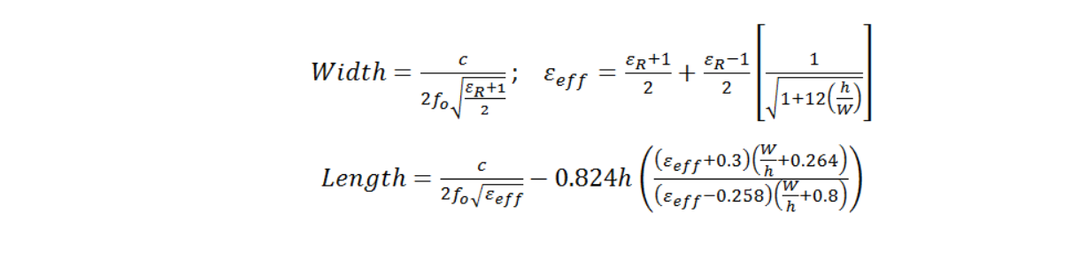Length of ground: 6h +L

Width of ground: 6h +L

-In our project:

Dielectric constant: 4.4

Height(h): 1.6mm

Resonant frequency: 5Ghz

**Diagram**

**Fig.1**

**Fig.2**

**V**  **STEPS FOR DESIGN AND SIMULATION**

The following steps can be followed for the design and simulation of a microstrip antenna at 5GHz: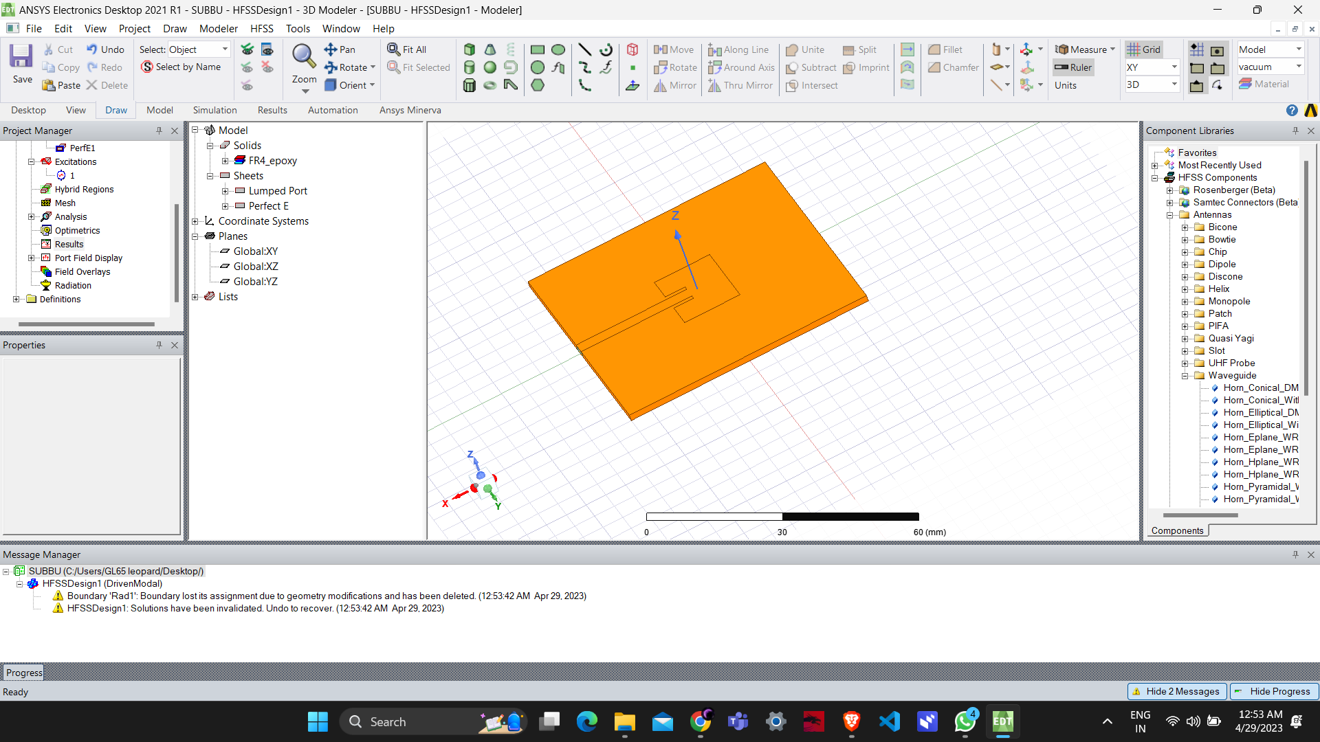

**Fig.3**

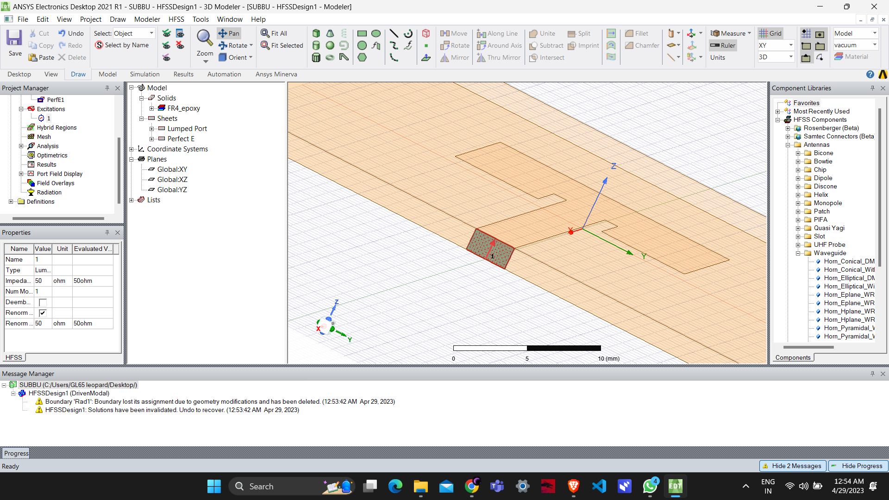

**Fig.4**

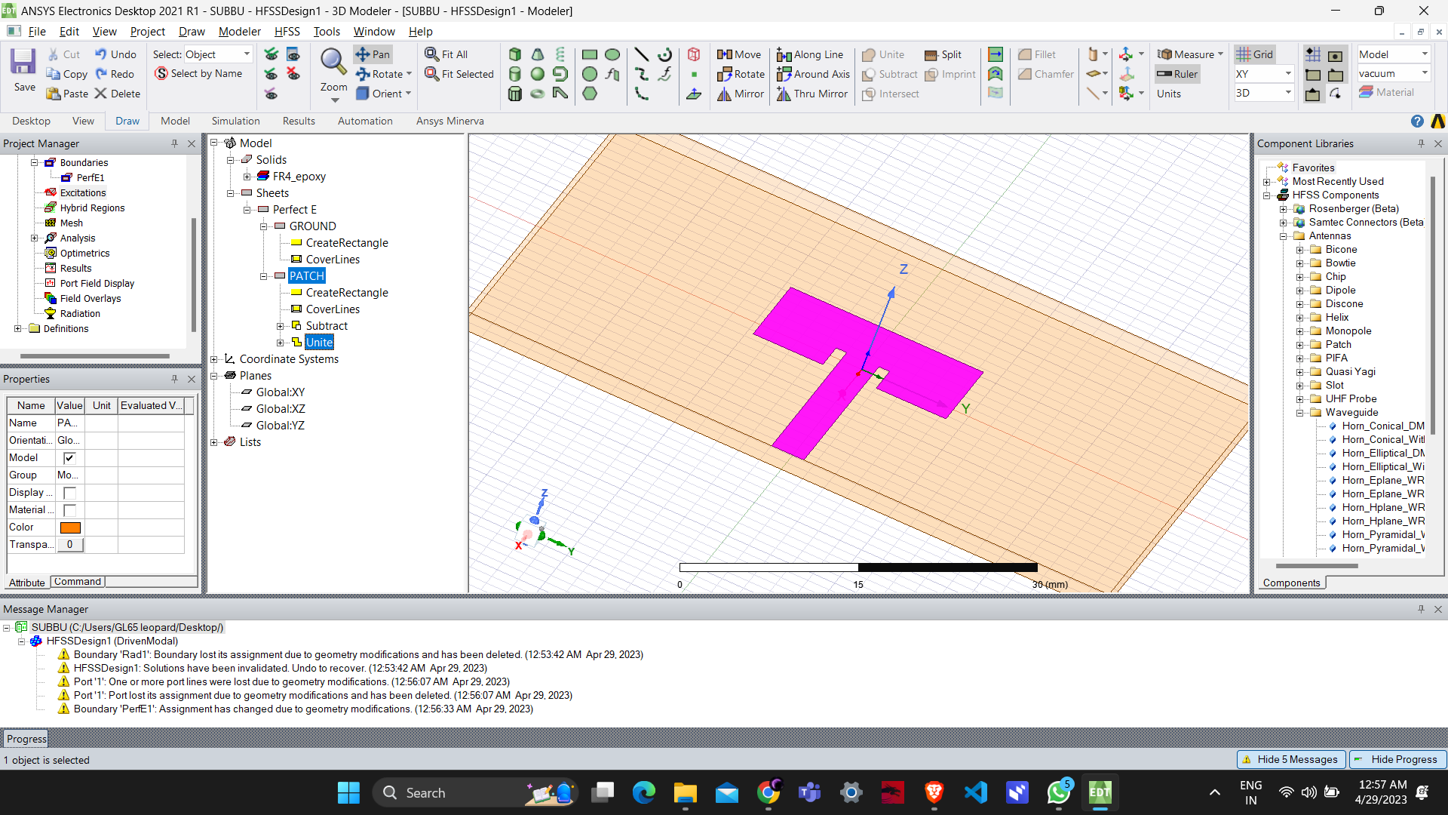

**Fig.5**

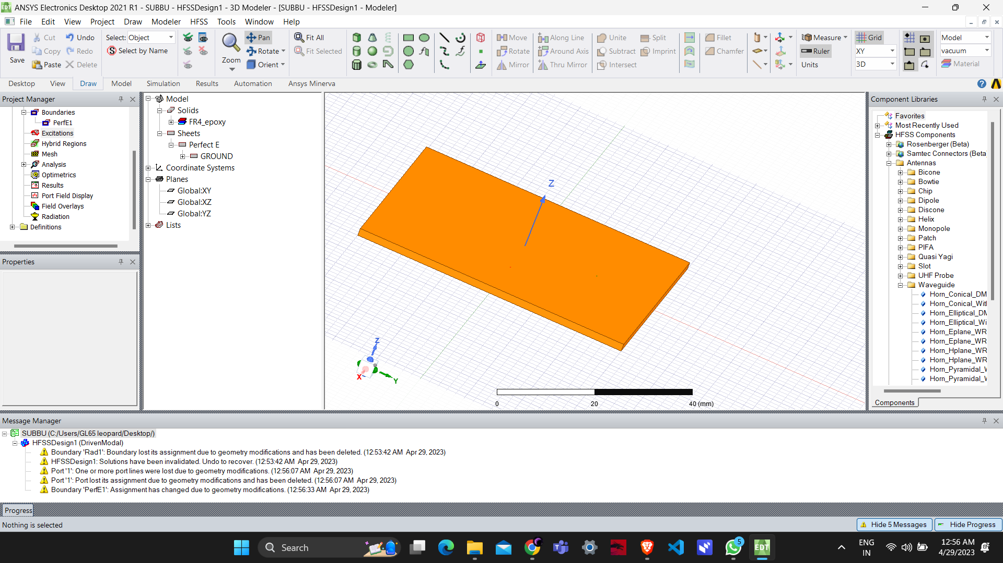

**Fig.6**

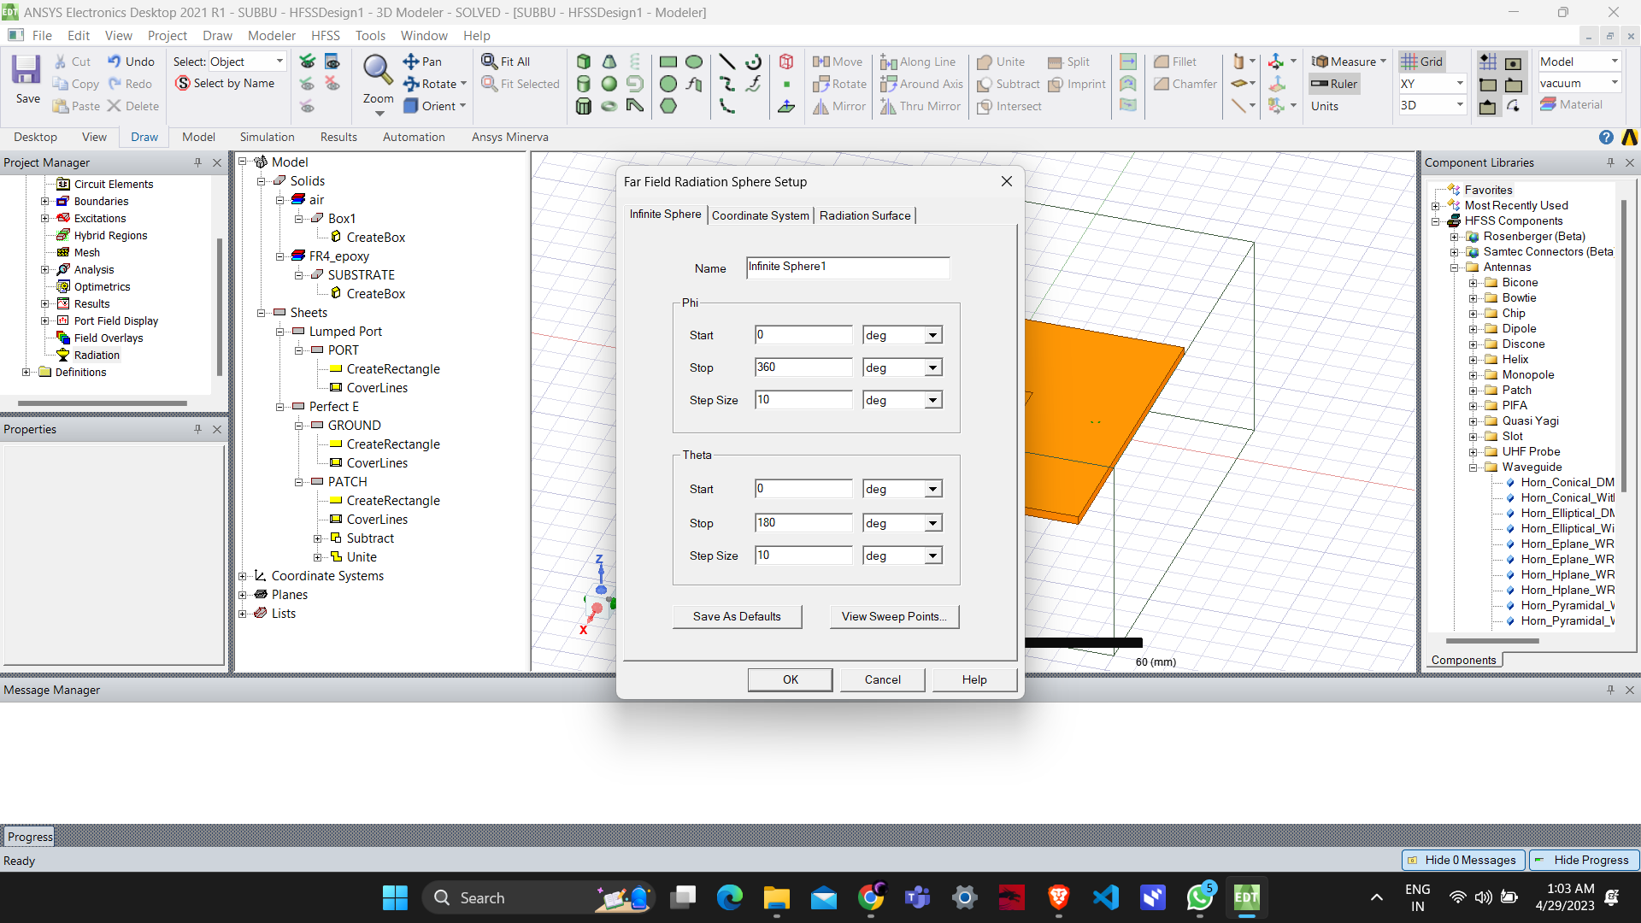

**Fig.7**

**VII ANSYS HFSS PLOTS FOR ANALYSIS**

**AND OPTIMIZATION**

ANSYS HFSS offers a variety of different plots that can be used to analyze the performance of microstrip antenna. Some of the commonly used plots are:

S parameter plot: In microstrip antenna simulation using HFSS, S parameter plot represents the frequency response of the antenna. It shows how much energy is reflected or transmitted by the antenna at different frequencies. The S parameter plot can be used to determine the resonant frequency and bandwidth of the antenna.

3D polar plot E field: A 3D polar plot of the electric field (E-field) shows the radiation pattern of the antenna in three dimensions. It helps to visualize how the antenna radiates energy in different directions. The polar plot shows the magnitude and phase of the E-field at different angles and distances from the antenna.

E - PLANE Radiation: E-plane radiation pattern represents the radiation of the antenna in the plane perpendicular to the direction of the E-field. It shows how the antenna radiates energy in the direction of the electric field. E-plane radiation pattern is useful in determining the directionality of the antenna and can be used to optimize the design of the antenna.

H- plane radiation: H-plane radiation pattern represents the radiation of the antenna in the plane perpendicular to the direction of the magnetic field. It shows how the antenna radiates energy in the direction of the magnetic field. H-plane radiation pattern is useful in determining the directionality of the antenna and can be used to optimize the design of the antenna.

Radiation pattern for E field plot: The radiation pattern for the E-field plot shows the energy radiated by the antenna in the direction of the electric field. It is a 2D plot that shows the magnitude and phase of the E-field in different directions.

Radiation pattern for H field plot: The radiation pattern for the H-field plot shows the energy radiated by the antenna in the direction of the magnetic field. It is a 2D plot that shows the magnitude and phase of the H-field in different directions.

Gain vs resonant frequency plot: The gain vs resonant frequency plot shows the gain of the antenna at different frequencies. It is a useful plot in determining the bandwidth and resonant frequency of the antenna. The gain is a measure of the antenna's efficiency in radiating energy in a particular direction. The resonant frequency is the frequency at which the antenna radiates most efficiently.

**VIII RESULT**

The results of the design and simulation of a microstrip antenna at 5GHz can vary based on the specific design parameters and simulation software used. However, the

following are some of the typical results that can be expected:

Radiation pattern: The radiation pattern of the antenna can be simulated and analyzed to determine the direction and strength of the electromagnetic waves radiated by the antenna.

Bandwidth: The bandwidth of the antenna can be simulated and optimized to ensure that the antenna can operate over a wide range of frequencies**.**

Impedance matching: The impedance of the antenna can be simulated and optimized to ensure that it matches the impedance of the transmission line and minimizes signal loss.

Gain: The gain of the antenna can be simulated and optimized to ensure that it provides sufficient signal strength for the intended application.

Efficiency: The efficiency of the antenna can be simulated and optimized to ensure that it maximizes the amount of power radiated in the desired direction.

Overall, the results of the design and simulation of a microstrip antenna at 5GHz should show that the antenna meets the desired specifications and performs well in its intended application.

The design and simulation of microstrip antennas at 5GHz is a crucial aspect of modern communication systems. By using simulation software and following a well-defined design methodology, a microstrip antenna can be designed and optimized to provide efficient and effective communication in various applications. The use of microstrip antennas at 5GHz offers numerous benefits, including their compact size, lightweight, and ease of integration with other circuit components. They also provide high gain and directional radiation patterns, making them suitable for point-to-point communication and satellite communication systems. Overall, the design and simulation of microstrip antennas at 5GHz is an important area of research that is constantly evolving as communication technology advances, and it is crucial for the development of modern wireless communication systems.

**Results/plot:**

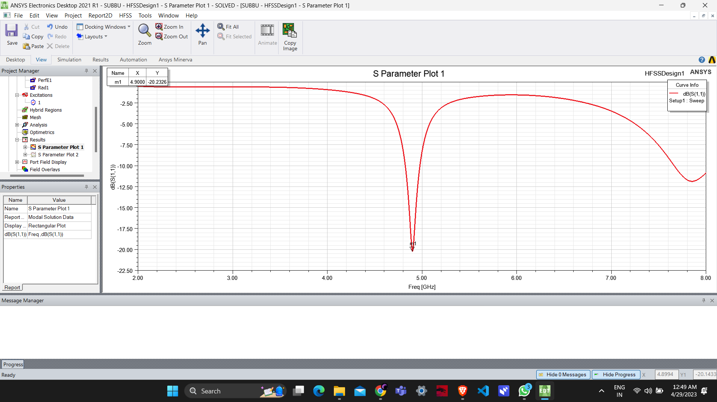

**Fig.8**

**RETURN LOSS**

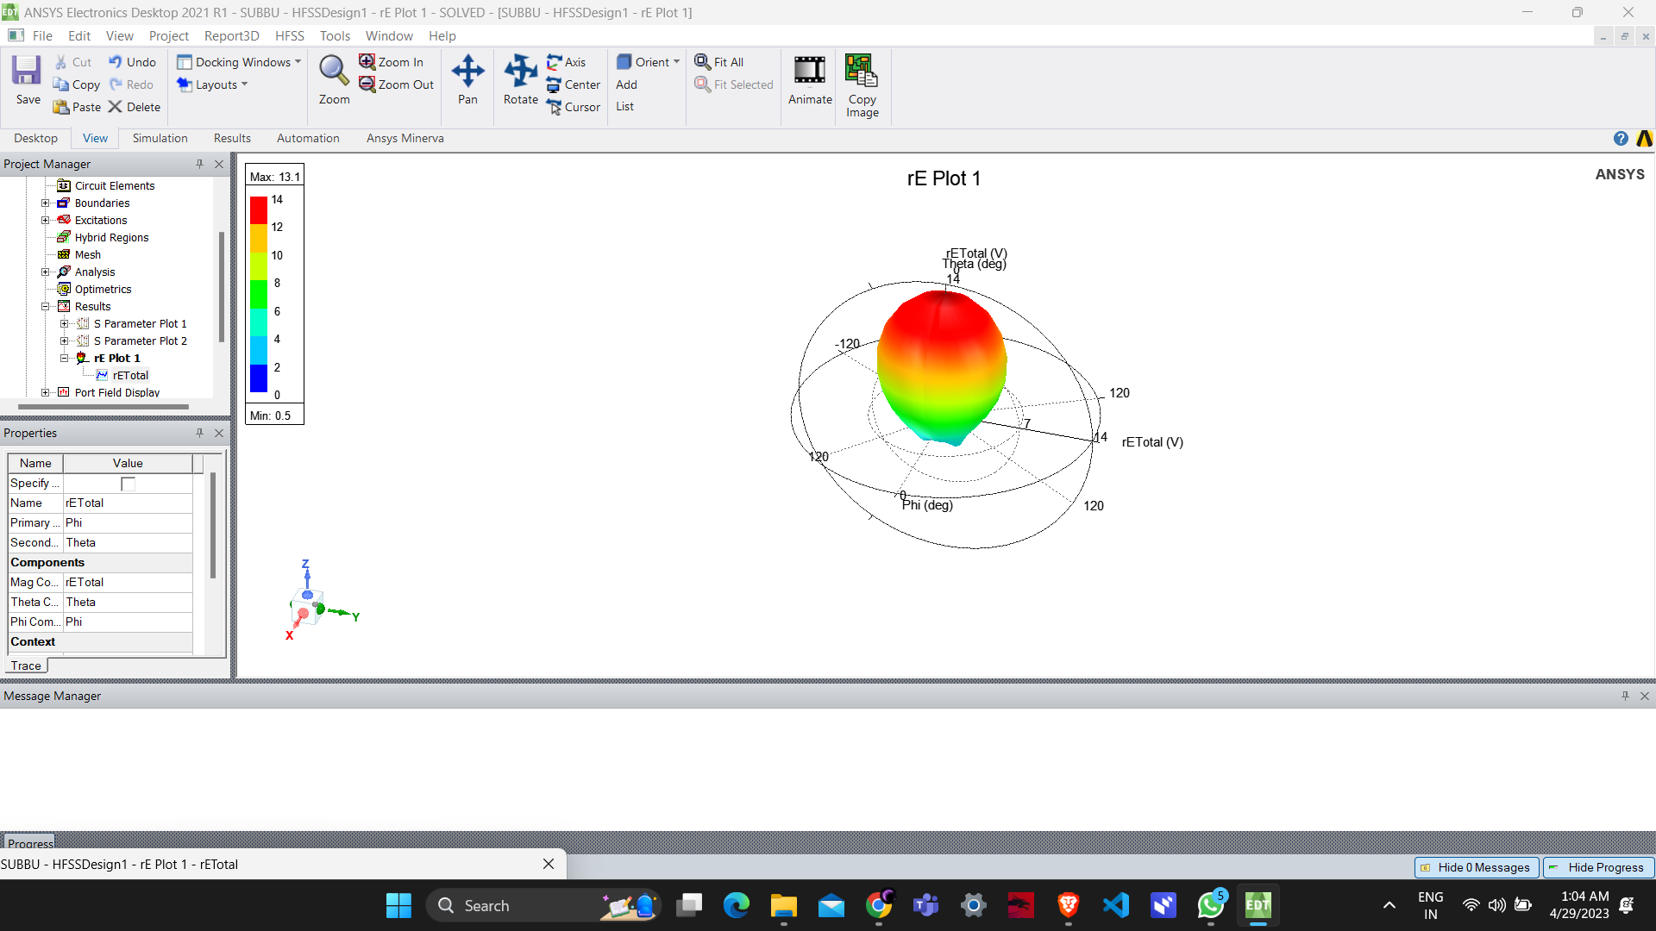

**Fig.9**

**3D- POLAR PLOT FOR E FIELD**

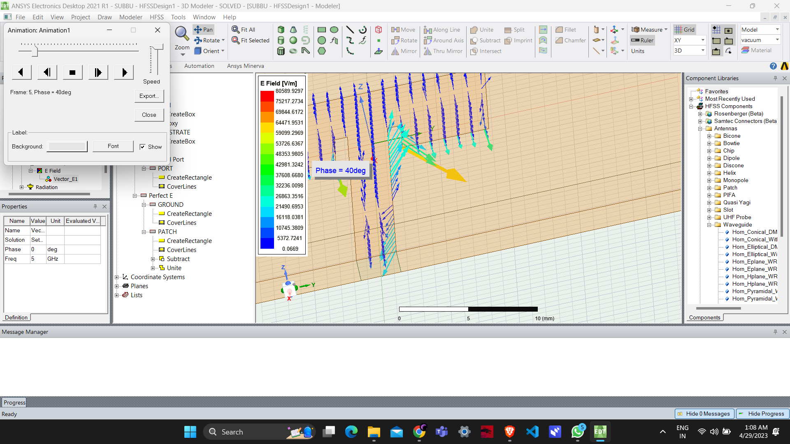

**Fig.10**

**E-PLANE RADIATION PLOT**

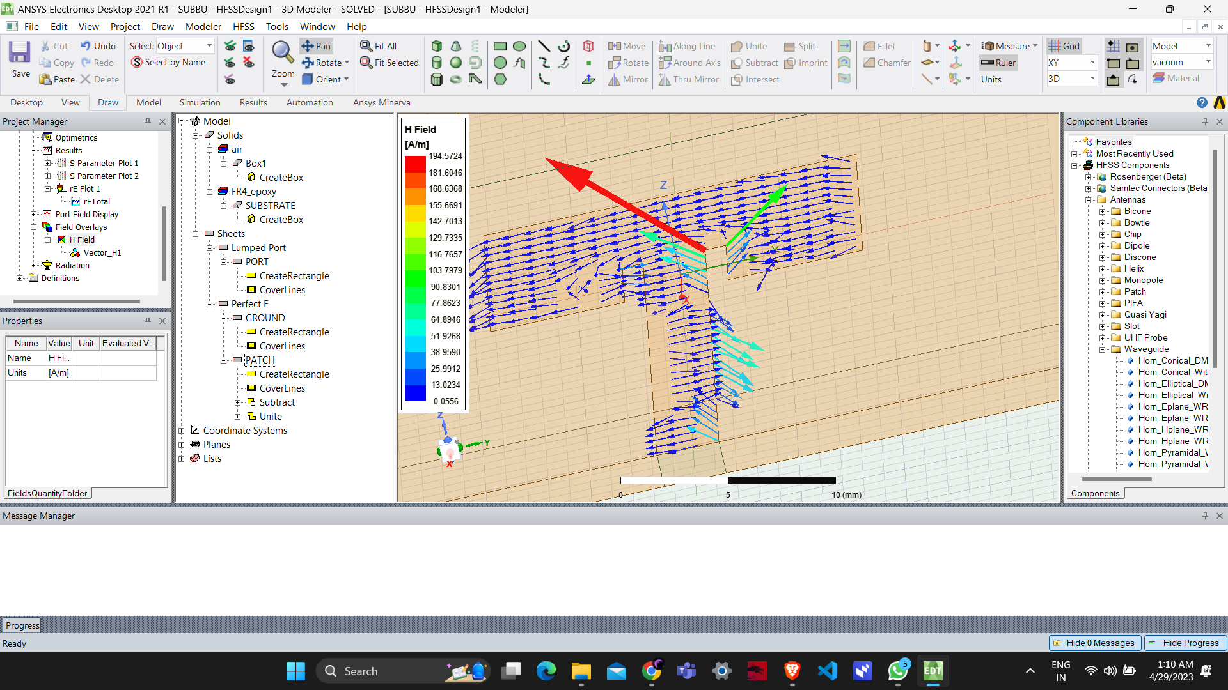

**Fig.11**

**H-PLANE RADITION PLOT**

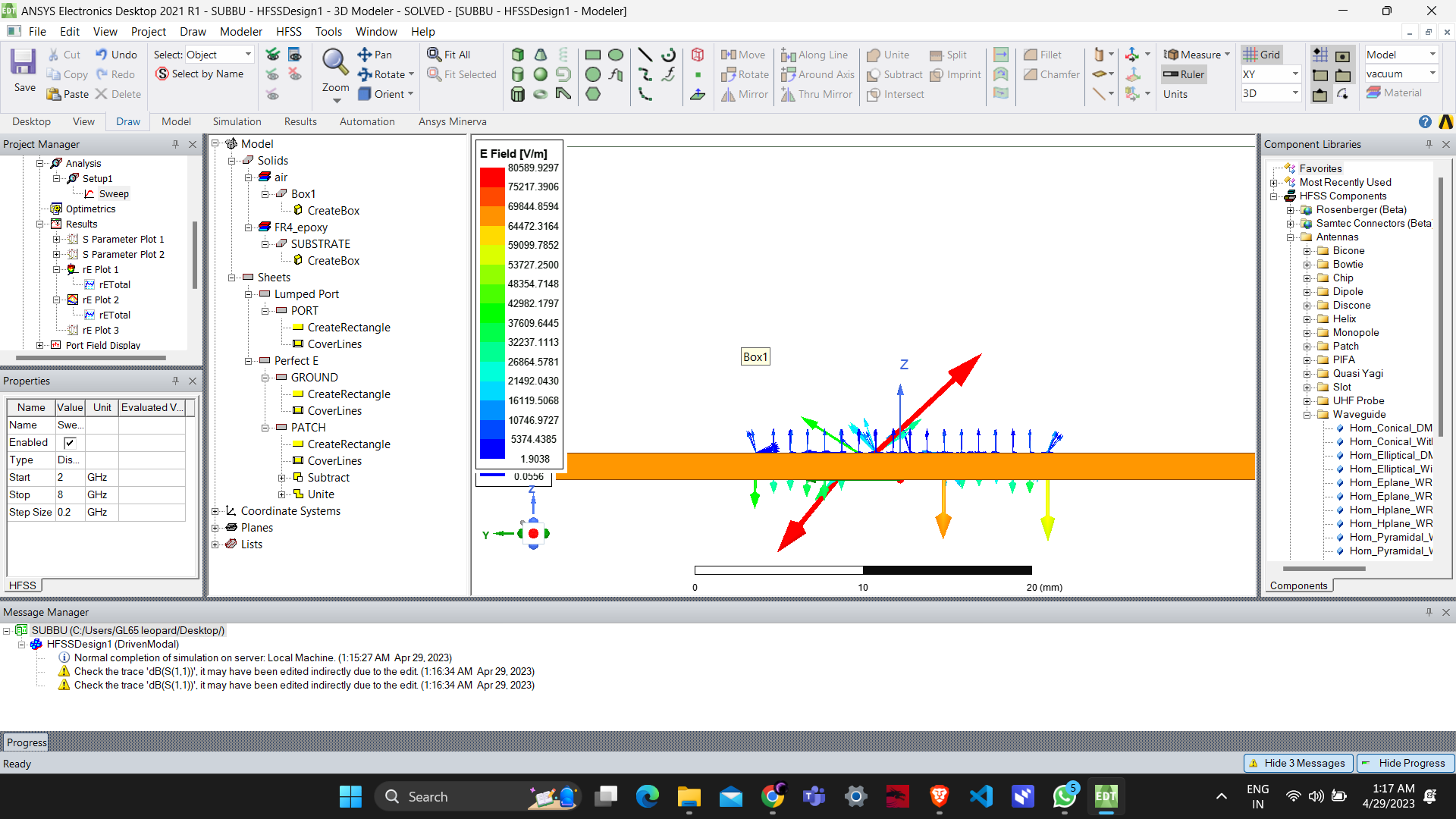

**Fig.12**

**SIDE VIEW OF E AND H PLANE RADITION**

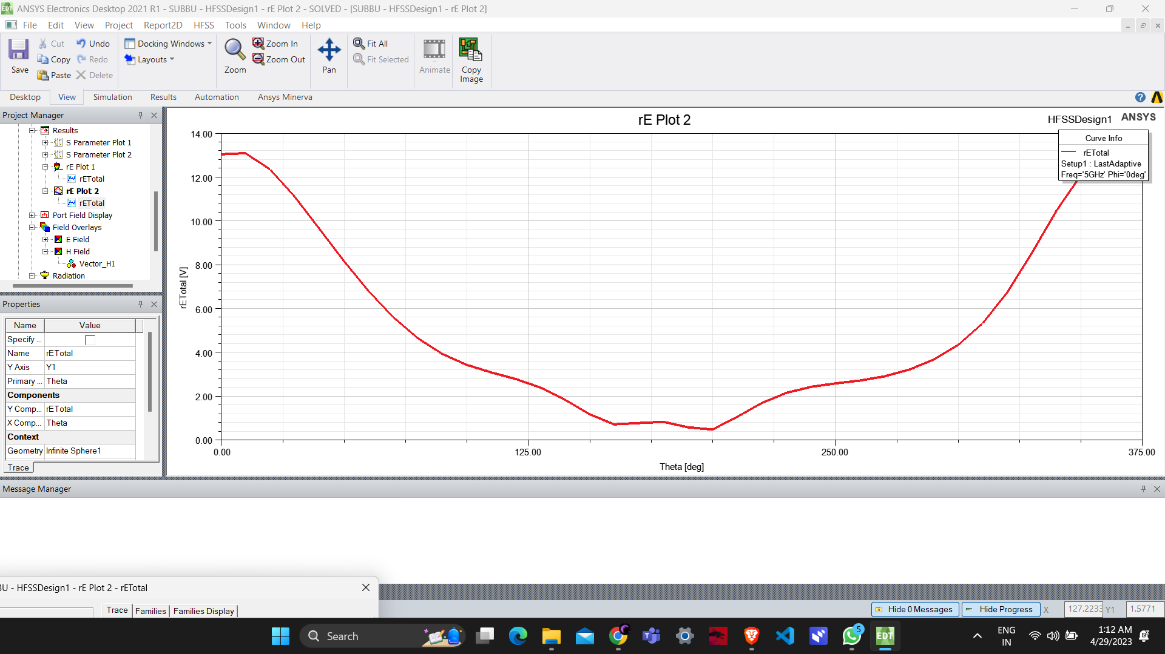

**Fig.13**

**RADITION PATTERN FOR E FIELD**

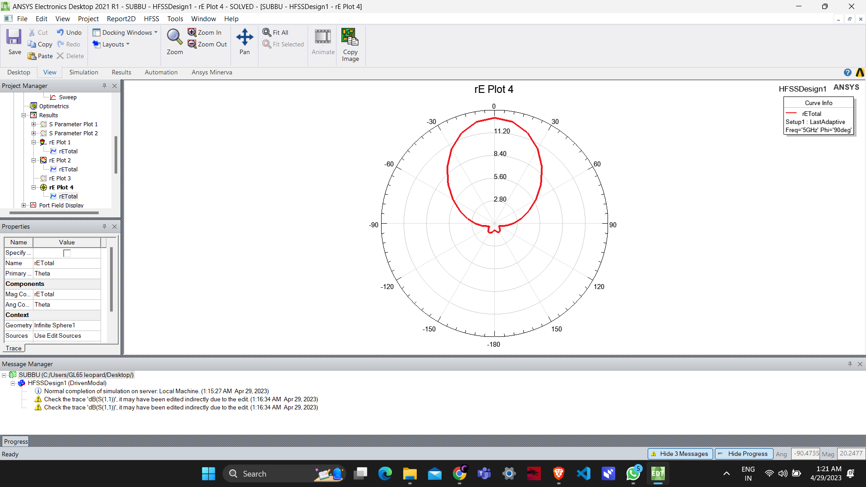

**Fig.14**

**RADITION PATTERN FOR H FIELD**

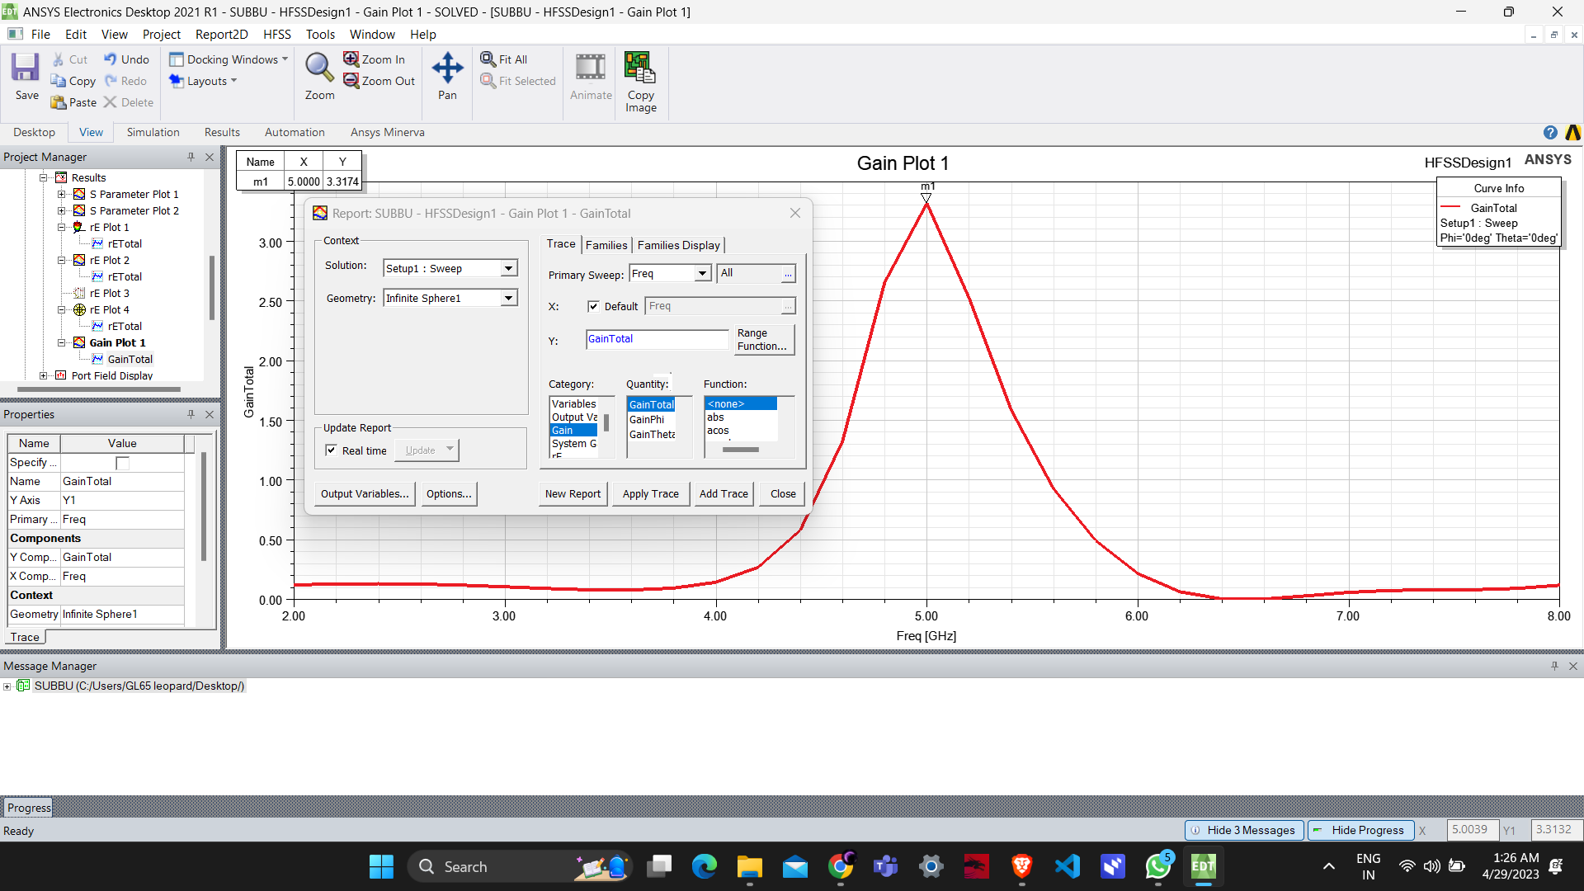

**Fig.15**

**GAIN VS RESONANT FREQUENCY PLOT**

**IX CONCLUSION**

In conclusion, the design and simulation of a microstrip antenna at 5GHz can be a complex process, but with careful attention to the design parameters and use of simulation software, it can result in a well-performing antenna that meets the desired specifications. By following the steps outlined in the methodology, including defining the design specifications, choosing a suitable substrate material, optimizing the antenna design through simulation, and verifying its performance through testing, a microstrip antenna can be designed that provides efficient and effective communication at 5GHz. The results of the simulation and testing should guide the designer in making any necessary adjustments to optimize the antenna's performance. Overall, the use of microstrip antennas at 5GHz has numerous applications in various fields, including wireless communication, radar systems, and satellite communication, among others**.**

**X ACKNOWLEGEMENT**

We would like to acknowledge the contributions of MEMS LAB faculties for their efforts and contributions to the design and simulation of the parabolic antennas in this research project**.**

We would like to acknowledge the use of HFSS software for the electromagnetic simulation of the parabolic antennas in this research project.

**XI REFERENCE**

Garg, R., Bhartia, P., Bahl, I., & Ittipiboon, A. (2001). Microstrip antenna design handbook. Artech House Publishers.

Pozar, D. M. (2011). Microwave engineering. John Wiley & Sons.

Balanis, C. A. (2016). Antenna theory: analysis and design. John Wiley & Sons.

ANSYS HFSS Documentation: https://www.ansys.com/products/electronics/ansys-hfss/documentation

Huang, J., Xie, H., & Zhou, Z. (2019). Design and simulation of a circularly polarized microstrip antenna based on ANSYS HFSS. Journal of Physics: Conference Series, 1171(1), 012013.

Khan, M. M., & Ahmed, S. (2016). Design of microstrip patch antenna and simulation using HFSS. International Journal of Advanced Research in Electrical, Electronics and Instrumentation Engineering, 5(2), 860-866.